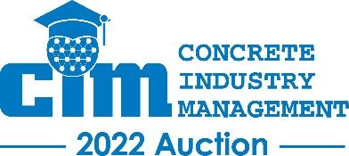
Wednesday, January 19, 2022
Las Vegas Convention Center, Las Vegas, NV
Silent Auction Time: 11:00am – 12:45pm PST
Live Auction Time: 1:00pm til finished PST

***Registration and Participation Instructions***

If you will be on-site in Las Vegas at World of Concrete:
Step 1: Use your cell phone and text CIM2022 to 76278 and follow the instructions. This will give you access to the silent auction site, where you will be able to place bids on all the items in the silent auction. This is how you will continue to bid on silent auction items through the event. This process will also pre-register you for the live auction. If you would prefer to register using your computer, visit https://CIM2022.givesmart.com
Step 2: Beginning at 11am PST on the morning of the auction, come to room W103 to participate in the silent auction and pick up your bid book for the live auction, at which time you will be provided with your bidder number. You will use this bidder number to bid on all the items in the live auction (the phone app is not used for bidding on live auction items). The live auction will take place beginning at 1pm PST across the hall in room W106.

If you will NOT be on-site in Las Vegas at World of Concrete:
Step 1: Visit CIM Charity Auction for details and to register to bid in real-time through Ritchie Bros.' online portal on all of the items in the LIVE auction. Please note: Administrative fees and bid deposits waived for all CIM Auction bidders. You are encouraged to register at least 72 hours prior to the auction to ensure your account is set up prior to the start of the auction.
Step 2: On your cell phone, text CIM2022 to 76278 and follow the instructions. This will give you access to the silent auction website, where you are able to place bids on all the items in the silent auction. This is how you will continue to bid on silent auction items throughout the event.
For a list of all of the items to be auctioned, separated by category, click here. Check back often as new items are added daily!
Questions or difficulties registering? Contact Nicole Maher at nmaher@nrmca.org or 301-325-4156 for assistance.

